UPPAAL SMC Tutorial :

Uppaal is a toolbox for verification of realt-time systems represented by (a network of) timed automata
extended with integer variables , structured data types, and channel synchronization. The tool is jointly developed by Uppsala University ans Aalborg universyt. [1]

- Transitions as guards (Enabling conditions)
A transition cannot occur if its guard is invalid.
- Locations as invariants (Safety specifications)
A location must be left before its invariant becomes invalid.

Note:
Invariants are the only way to force transitions to occur.

Extension to Timed Automata

Some of the additional features of the UPPAAL modelling language are the following

Urgent locations: Time is not allowed to pass when the system is an urgent location. They are semantically equivalent to adding an extra clock x that is reset on all incoming edges, and having an invariant x<= 0 on the location.

Committed locations: A commited location is the same as a urgent location but the next transition must involve an outgoing edge of at least one of the committed locations of the network.

Uppaaltest -q

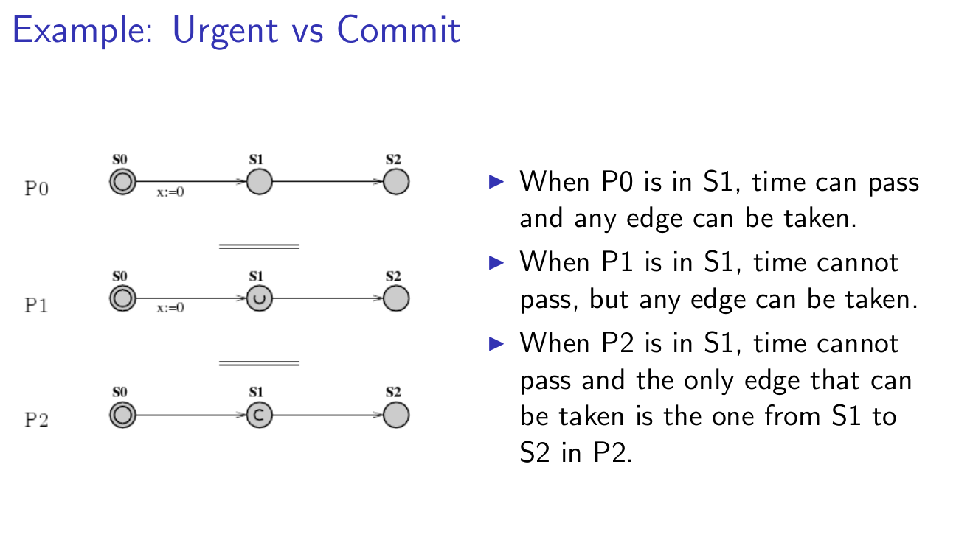

Path Formulae:

- reachability E <> @
- safety A[] @ and E <> @
- liveness A[]@ and @→Y (I.e @ leads to Y )

A : All → [] always
E : Exist → <> Eventually

Bibliography:

1.- uppaal smc tutorial
2.-

